Download project from spring initializer from below link

<https://start.spring.io/>

Select following

Project : Java

Spring Boot : 3.4.2

Project metadata : Rename the Artifact Ex. Ticket

Packaging : Jar

Java : 21

Click on Generate

It will generate a zip file ticket.zip. Exteact it and copy where you created folder Ex. MyPracticals

Open IntellijIdea

Click File->New->project from existing sources

Then select the project where you copied “MyPracticals”

Select ticket->click oK

Select Maven and click on Create and then click on new window

Now our code is here

Create a repository in github <https://github.com/>

Login to account and create repository

Click on repositories and then click on New

Enter Repository Name

Select public **to access everyone**

Initialize this repository with Add a README file

Add gitignore Java

Check the branch whether it is main or master (Make default branch is Master)

Click on Create Repository

Below ticket repository is created

 Now open Intellij IDEA for linking local repo with GitHub repo.

Click on VCS->Enable version control Integration

Select Git and click OK

Click on Git -> Manage Remotes

Then click on + and add the remote repo link

Click on OK

Then hit below commands below are the outputs

**Git pull origin master**

**Git add –all**

**Git commit -m “codeRefactor”**

**Git push origin master -f**

Now refresh ticket repo page.

Code are pushed to GitHub repo ticket.

**Adding new java class Ex. Train**

**Right click on com.example.ticket**

Click on Enter

Now Train class added

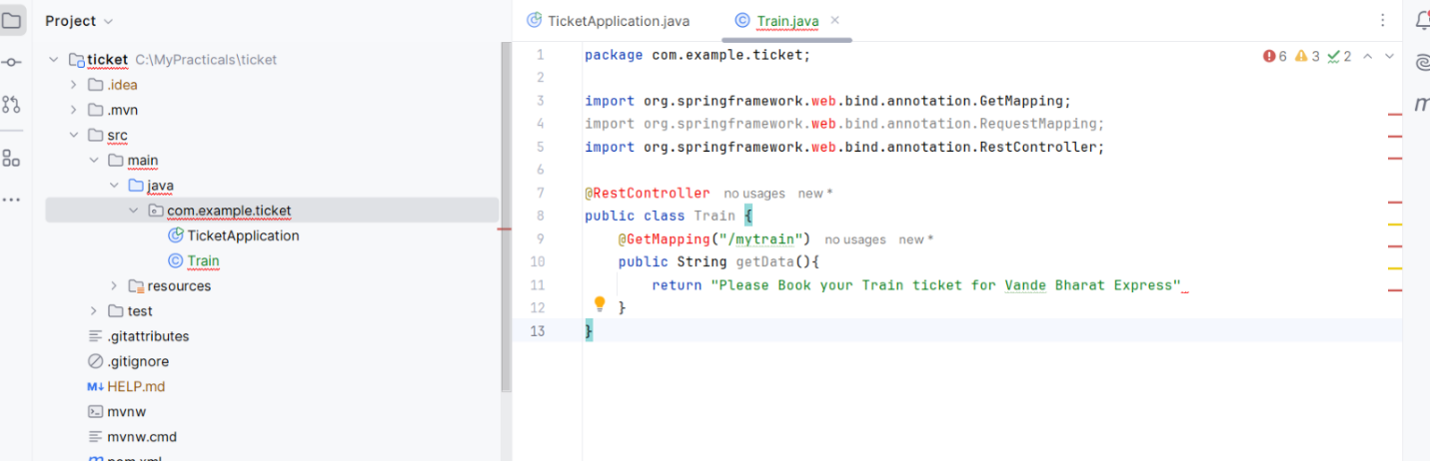

Compile code using mvn clean compile

Now mvn clean package for packaging

